May 21, 2023

Greetings New Beginning Church Family,

Over the past few months, my family and I have been seeking discernment on what the next steps into God’s call look like for us as well as for New Beginning Church. Through this time of discernment, God has been moving in our hearts and minds in new and exciting ways. Particularly, God has made it abundantly clear to us that our next step in following God’s call is to serve as pastor and ministry planter in Frederick.

In following this call to be sent by New Beginning to start this new expression of church in Frederick, I need to resign my duties as Lead Pastor of New Beginning Church. As such, I am resigning from the position of Lead Pastor effective June 30, 2023.While this has been one of the most difficult decisions of my ministry, it is also one that I am excited for and certain of God’s movement in.

Over the next few weeks, our District Superintendent, Dr. David Bowser, will work with our Church Board to begin the process of calling a new pastor to New Beginning.

I am deeply grateful and thankful for the 10 years of ministry at New Beginning. Be assured of my prayers for you as you look toward God’s next.

Grace & Peace,

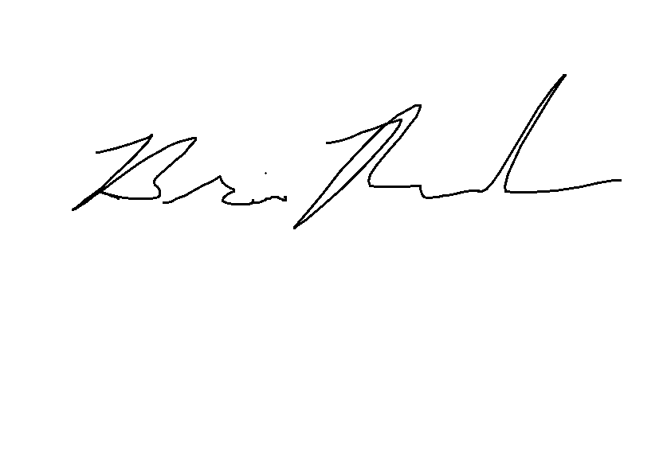

Brian S. Remsch, Lead Pastor



**12350 Jesse Smith Rd. Mount Airy, MD 21771**

**Office: 301.865.7300 Fax: 301.865.0625**

Brian Remsch

Lead Pastor

Lexa Herbert

Director of Children’s and Youth Ministries

Donald Seyler

Pastoral Care and Visitation Pastor

Liz Wright

Director of Discipleship